Dr. Shradha Lakhera
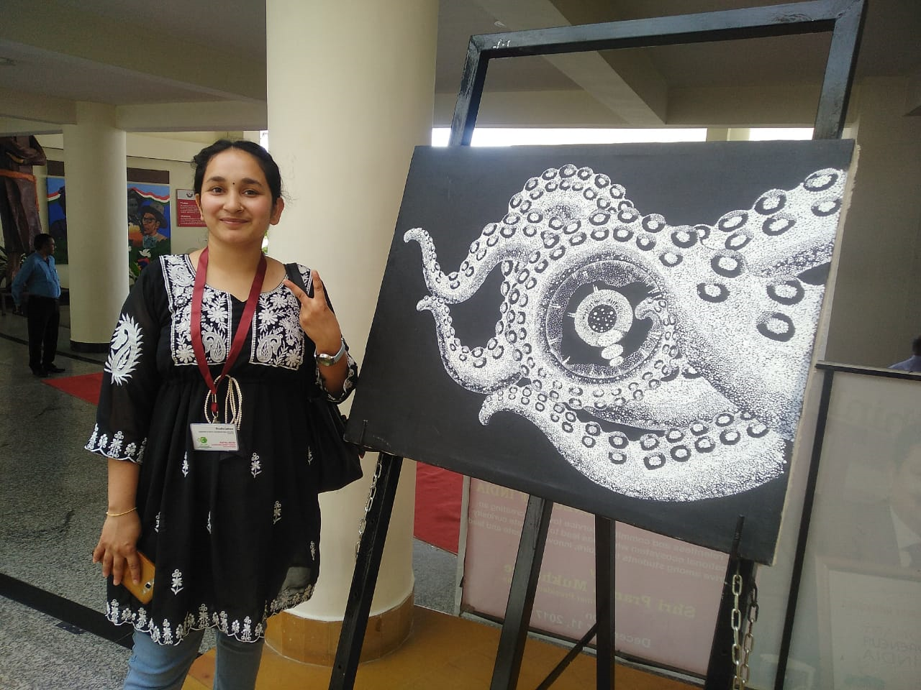
[M. Sc (Physics, 2019; PhD Physics, 2025)]
Email: shradhalakhera11@gmail.com
Date of birth: 11th July 1997
Mobile no: 8630883181
Language: English and Hindi
Domicile Address: Village-Shivpur, near Resham farm P.O.-
Kotdwara, District-Pauri Garhwal, Uttarakhand, India 246149
Current Address: Uttarakhand Open University, Teenpani bypass road, behind transport nagar, Haldwani, Uttarakhand, 263139
SUBJECT INTEREST
- Solid state Physics
- Condensed Matter Physics
- Theoretical Physics
- Quantum Mechanics
- Spectroscopy
- Nanotechnology

AREA OF RESEARCH
- Non-linear optics
- Optical limiting liquids and thin films
- Density functional theory
- Spectroscopy
- Dye-synthesized solar cells
- Computer-assisted drug designing
- in silico molecular modeling

EDUCATIONAL DETAILS
- Ph.D. in Physics (2021-2024; AWARDED January, 2025) from Uttarakhand Open University, Haldwani, Uttarakhand under Professor Kamal Devlal, Head, Dept of Physics.

- M.Sc. (Physics) in 2019 from Dr. P. D. B. H. Govt. P. G. College, Kotdwara (Affiliated by H.N.B. Garhwal, Central University, Srinagar) with a 7.6 CGPA.

- B.Sc. (Physics, Chemistry, and Mathematics) in 2017 from Dr. P. D. B. H. Govt. P. G. College, Kotdwara (Affiliated by H.N.B. Garhwal, Central University, Srinagar) with 65 % marks.

- 12th in 2014 with subjects Physics, Chemistry, Maths, and Computer science from S.G.R.R. Public School, Kotdwara (CBSE board) with 75%.

- 10th in 2012 from S.G.R.R. Public School, Kotdwara (CBSE board) with 9.0 CGPA.

AWARDS, SPECIAL ACHIEVEMENTS & MEMBERSHIP
- “Young scientist” awardee from 16th USSTC 2022 by Uttarakhand Council for Science and Technology (UCOST), Dehradun, held at Graphic Era University, Dehradun.

- “Young Women Scientist Excellence Award” from Uttarakhand Science, Education and Research Centre (USERC), Dehradun in 2022.

- Recognition certificate from ‘Uttarakhand Open University’, for outstanding research contributions in 2022.

- Best oral presentation at “International Conference on Functional Materials and its applications aspects 2023”, conducted by SIMATS deemed university, Chennai. India.

- Have 25+ research publications.

- Reviewer of International journals like Journal of Fluorescence, Structural Chemistry, Discover Chemistry, and Nature Scientific Reports.

- Highest scorer in M.Sc at College level.

PROJECTS AND EXPERIENCE
- Worked as a research fellow in a USERC-funded project, “Synthesis and characterization of Nitrogen and oxygen-rich organic compound for optical nonlinearity and Laser limiting applications” under PI Dr. Meenakshi Rana.

- Visiting scholar on a short-term project in 2024 issued by INUP-IIT Delhi for the fabrication of Coumarin-based Dye-synthesized solar cells (PI: Dr. Kamal Devlal).

- Visiting scholar on a short-term project in 2025 issued by INUP-IIT Delhi for synthesis and characterization of Ag@ZnO/PVP nanocomposite films (PI: Dr. Meenakshi Rana).

- Co-author in UCOST-funded project, “A multistage in-silico identification and application of natural potential inhibitors of Uttarakhand region against different diseases” under PI Dr. Meenakshi Rana.

PUBLICATION DETAILS
https://scholar.google.com/citations?user=GC85EJ4AAAAJ&hl=en
ORCID: 0009-0004-5962-4667
https://www.researchgate.net/profile/Shradha-Lakhera-2?ev=hdr_xprf
INSTRUMENTATION AND CHARACTERIZATION
- Spin coating
- Hydrothermal treatment
- UV-Vis absorption spectroscopy
- FT-IR spectroscopy
- XRD spectroscopy
- TEM & HR-TEM
- FE-SEM
- Solar simulator
- EQE measurements
- Z-Scan
- Thickness profilometer
- Programming languages: C++ and Python
SOFTWARE AND COMPUTER HANDLING
- Gaussian and Gauss view
- Vesta
- Spartan
- SCAPS 1D
- Burai
- Quantum espresso
- Origin
- Crystal Explorer
- MS Office
- ADMET Databases
- Autodock Vina
- Pyrx

CONFERENCE ARTICLES
- S. Lakhera, M. Rana, K. Devlal, Investigation of Nonlinear Optical Responses of Organic Derivative of Imidazole: Imidazole-2-carboxaldehyde, IJMR. 114 (7-8) (2023) 555-563. https://doi.org/10.1515/ijmr-2021-8649 (Poster presentation at International conference on Energy and Advance Materials (ICEAM), 2021, JIIT, NOIDA)

- S. Lakhera, M. Rana, K. Devlal, A. Ghosh, In Silico Investigation of phytoconstituents of medicinal herb ‘piper longum’ against SARS-Cov-2 by molecular docking and molecular dynamics analysis. (Oral presentation at Uttarakhand state science and Technology Congress (USSTC, 2022), Uttarakhand State Council for Science and Technology UCOST, Govt of Uttarakhand).

- S. Lakhera, M. Rana, K. Devlal Investigation of Nonlinear Optical Response of Organic Compound Pyrrolidine-2,5-dione, DAE Solid State Physics Symposium. 55 (2022) 585-586. ISBN No: 81-8372-085-4 (BHABHA ATOMIC RESEARCH CENTRE, MUMBAI)

- S. Lakhera, M. Rana, K. Devlal, Modelling the reactivity of Entrectinib and evaluation of its potential anticancer activity using Molecular Docking approach, DAE Solid State Physics Symposium 55 (2022) 583-584. ISBN No: 81-8372-085-4 (BHABHA ATOMIC RESEARCH CENTRE, MUMBAI

- S. Lakhera, M. Rana, K. Devlal, V. Dhuliya, Utilization of 1, 3-dinitropyrene as a Potential Photosensitizer for the Development of Solar Cells (Oral presentation at Uttarakhand state science and Technology Congress (USSTC, 20223), Uttarakhand State Council for Science and Technology UCOST, Govt of Uttarakhand).

- S. Lakhera, M. Rana, V. Dhuliya, P. Chowdhury, Optoelectronic and anti-cancerous activity of Indole-7-carboxaldehyde. Opt Quant Electron. 57 (2025) 91. https://doi.org/10.1007/s11082-024-08002-1 (Published through International conference on Energy and Advance Materials (ICEAM), 2023, JIIT, NOIDA).

- S. Lakhera, M. Rana, K. Devlal, V. Dhuliya, D. Padaliya, Enhancement of the Electronic and Optical Properties of Superalkali Metal Adsorbed Al₁₀N₁₀ Nanocage. (Oral presentation at 1st International Conference on Innovations & Future Prospects of Advanced Materials (ICFPAM, 2023), at K. R. M. University, Haryana).

- S. Lakhera, M. Rana, K. Devlal, V. Dhuliya, L. P. Purohit, A. Dhanusha, T. C. S. Girisun, Exploring the nonlinear optical limiting activity of para-aminobenzoic acid by experimental and DFT approach. (Oral presentation at International Conference on Functional Materials and its applications aspects (ICFMAA, 2023), at SIMATS deemed university, Chennai. India.

- S. Lakhera, M. Rana, K. Devlal, V. Dhuliya, Km. Shakshi, S. Roy, Morphology and Photostability of Low-cost Coumarin based Dye-Sensitized Solar Cells (Oral presentation at International conference on Energy and Advance Materials (ICEAM, 2023) JIIT, NOIDA).

- S. Lakhera, K. Devlal, M. Rana, Large hyperpolarizability and nonlinear optical activity of the adsorbed complex of para-aminobenzoic acid and 7-diethylamino 4-methyl coumarin. (Oral presentation at Megnad Saha Memorial International Conference on Frontiers of Physics (MSMICFP, 2023) at Fept of Physics, University of Allahabad, Prayagraj, UP).

- S. Lakhera, M. Rana, K. Devlal, V. Dhuliya, L. P. Purohit, A. Dhanusha, T. C. S. Girisun, Enhanced optical power limiting and Photovoltaic characteristics of coumarin functionalized with silver nanoparticles (Poster presentation at INUP User’s awareness workshop, 2024, INUP, IIT-Delhi).
RESEARCH COLLABORATIONS
- Indian Nanoelectronics User Program, INUP-i2i, IIT-Delhi.

- Department of Physics and Materials Science and Engineering, Jaypee Institute of Information Technology, Noida, Uttar Pradesh 201309, India.

- Department of Chemistry, Biochemistry and Forensic Science, Amity School of Applied Sciences, Amity University Haryana, Manesar, Gurgaon 122413, Haryana, India.

- Semiconductor Research Laboratory, Department of Physics, Gurukula Kangri University, Haridwar, 249404, Uttarakhand, India.

- Microbiology Division, Department of Botany, Guwahati University, Guwahati 781014, Assam, India.

- Nanophotonics Laboratory, Department of Physics, Bharathidasan University, Tiruchirappalli, Tamil Nadu 620024, India.

- Photophysics Laboratory, Department of Physics, Centre of Advanced Study, DSB Campus, Kumaun University, Nainital 263002, Uttarakhand, India.

- Department of Physics, Saveetha School of Engineering, Saveetha Institute of Medical and Technical Sciences, Thandalam, Chennai 602105, Tamil Nadu, India.

- Department of Physics and Centre of Excellence in Nanosensors and Nanomedicine, School of Engineering and Applied Sciences, Bennett University, Greater Noida, 201310, India

- Institute of Low Temperature and Structure Research, Polish Academy of Sciences, Ok´ olna 2 str., 50-442 Wrocław, Poland.

- Department of Pharmaceutical Chemistry, Faculty of Pharmacy, Erciyes University, Kayseri 38039, Turkey.

LIST OF PUBLISHED ARTICLES
- S. Lakhera, M. Rana, V. Dhuliya, L. P. Purohit, A. Dhanusha, T. C. S. Girisun, S. Sharma, P. Chowdhury, Km Sakshi, S. Roy, D. Kumar, Enhancement of Optical Limiting Activity of Para-Aminobenzoic Acid using Silver Nanoparticles. Nature Scientific Reports. (Accepted)

- S. Lakhera, M. Rana, A. Dhanusha, T.C. Sabari Girisun, S. Sharma, P. Chowdhury, Indole-7-carboxaldehyde functionalized silver and gold nanoparticles as novel metal-organic laser power limiting composites, Photonics and Nanostructures - Fundamentals and Applications. 64 (2025) 101386. https://doi.org/10.1016/j.photonics.2025.101386

- V. Dhuliya, L.P. Purohit, S. Lakhera, M. Rana, Potentiality of 1-(4-nitrophenyl)-2-pyrrolidine methanol as an efficient photosensitizing material: A multi-solvent first principle DFT study, Materials Science in Semiconductor Processing. 188 (2025) 109231. https://doi.org/10.1016/j.mssp.2024.109231

- S. Lakhera, M. Rana, V. Dhuliya, Enhancement of the electronic and optical properties of superalkali metal adsorbed Al10N10 nanocage, Materials Science in Semiconductor Processing. 185 (2025) 108882. https://doi.org/10.1016/j.mssp.2024.108882

- S. Lakhera, M. Rana, V. Dhuliya, L.P. Purohit, A. Dhanusha, T.C. Sabari Girisun, Enhanced nonlinear optical and optical limiting responses of 7-diethylamino-4-methyl coumarin functionalized with silver nanoparticles: A combined experimental and DFT study. Journal of Photochemistry and Photobiology A: Chemistry. 457 (2024) 115910. https://doi.org/10.1016/j.jphotochem.2024.115910

- S. Lakhera, M. Rana, K. Devlal, Comprehensive quantum chemical study of the associative complex of para-aminobenzoic acid and 7-diethylamino 4-methyl coumarin by adsorption and aromatic bridges. J Mol Model 30, 37 (2024). https://doi.org/10.1007/s00894-023-05816-w

- S. Lakhera, K. Devlal, M. Rana, V. Dhuliya, Influence of the substitution of different functional groups on the gas sensing and light harvesting efficiency of zero-dimensional coronene quantum dot: A first principle DFT study. Spectrochimica Acta Part A: Molecular and Biomolecular Spectroscopy 308 (2024) 123737. https://doi.org/10.1016/j.saa.2023.123737

- M. Rana, S. Lakhera, K. Devlal (2023). Detailed quantum chemical, ADMET, reactivity, and molecular docking interaction analysis of potential phytochemicals from Asparagus racemosus targeting HIV enzyme/DNA receptors. Life in Silico, 2(1), 1–16. Retrieved from https://life-insilico.com/index.php/pub/article/view/10

- S. Lakhera, M. Rana, K. Devlal, Utilization of Methyclothiazide Adsorbed with Malonamide for Quantum Chemical applications: A DFT and DFT-D2/D3 Studies. Optik. 295 (2023) 171485. https://doi.org/10.1016/j.ijleo.2023.171485

- S. Lakhera, M. Rana, K. Devlal, Nonlinear optical response of Silver trimer adsorbed para-aminobenzoic Acid: A DFT study. Phys. Scr. 98 (2023) 11519. https://doi.org/10.1088/1402-4896/ad0084

- S. Lakhera, M. Rana, K. Devlal, N. Kanagathara, A. Dhanusha, T.C. Sabari Girisun, S. Sharma, P. Chowdhury, Two-photon absorption and optical limiting in 7-diethylamino-4-methyl coumarin, Journal of Photochemistry and Photobiology A: Chemistry (2023) 115216. https://doi.org/10.1016/j.jphotochem.2023.115216

- S. Lakhera, M. Rana, K. Devlal, Potential natural inhibitors as strong anti‐viral agents: rigid and sequential docking analysis. Life in Silico. 1(1) (2023) 34–47. https://life-insilico.com/index.php/pub/article/view/9
- S. Lakhera, M. Rana, K. Devlal, S. Sharma, P. Chowdhury, V. Dhuliya, S. Panwar, Sagar L. P. Purohit, A. Dhanusha, T. C. Girisun, Exploring the Nonlinear Optical Limiting Activity of Para-Aminobenzoic Acid by Experimental and Dft Approach. Journal of Photochemistry and Photobiology A: Chemistry. (2023) 114987. https://doi.org/10.1016/j.jphotochem.2023.114987

- S. Lakhera, K. Devlal, M. Rana, A. Ghosh, In-Silico Investigation of Inhibiting Property of Phytoconstituents of Medicinal Herb ‘Aconitum Heterophyllum’ Against Omicron Variant of SARSCoV-2. https://doi.org/10.21203/rs.3.rs-1637533/v1

- S. Lakhera, K. Devlal, M. Rana, V. Dhuliya, N. Pandey, Non-Linear Optical Behavior of 2,9-Dimethylquinacridone with Adsorbed Gold and Silver Nanoclusters, Optik. (2023) 170983. https://doi.org/10.1016/j.ijleo.2023.170983

- S. Lakhera, M. Rana, K. Devlal, N. Kanagathara, J. Janczak, Photovoltaic Characteristics of Organic Heterocyclic2,9-dimethyl Quinacridone in Different Solvents Using DFT Approach, Journal of Photochemistry and Photobiology A: Chemistry (2023) 114664, ISSN 1010-6030. https://doi.org/10.1016/j.jphotochem.2023.114664

- S. Lakhera, K. Devlal, M. Rana, V. Dhuliya, Computational study of non-linear optical and electrical properties of 1,3-dinitropyrene. Opt Quant Electron 55, 85 (2023). https://doi.org/10.1007/s11082-022-04371-7

- S. Lakhera, K. Devlal, M. Rana, Investigation of the electronic and optical activity of halogen-substituted 2-nitrotoulene by density functional theory. Opt Quant Electron 55, 292 (2023). https://doi.org/10.1007/s11082-023-04569-3

- S. Lakhera, M. Rana, K. Devlal, Influence of Adsorption of Gold and Silver Nanoclusters on Structural, Electronic, and Nonlinear optical properties of Pentacene-5, 12-dione: A DFT study, Opt Quant Electron. 55, 178 (2023). https://doi.org/10.1007/s11082-022-04422-z

- S. Lakhera, M. Rana, K. Devlal (2022) Theoretical study on spectral and optical properties of essential amino acids: a comparative study, Opt Quantum Electron. 54:714 https://doi.org/10.1007/s11082-022-04118-4

- S. Lakhera, M. Rana, K. Devlal, I. Celik, R. Yadav, A comprehensive exploration of pharmacological properties, bioactivities and inhibitory potentiality of luteolin from Tridax procumbens as anticancer drug by in-silico approach, Struct. Chem. (2022). https://doi.org/10.1007/s11224-022-01882-7

- S. Lakhera, K. Devlal, M. Rana, V. Dhuliya, Quantum Mechanical Study of Three Aromatic Bioactive Fatty Alcohol Compounds with Nonlinear Optical and Potential Light Harvesting Properties, Opt. Mater. 129 (2022) 112476. https://doi.org/10.1016/j.optmat.2022.112476

- S. Lakhera, K. Devlal, M. Rana, I. Celik, Study of nonlinear optical responses of phytochemicals of Clitoria ternatea by quantum mechanical approach and investigation of their anti-Alzheimer activity with in silico approach. Struct Chem (2022). https://doi.org/10.1007/s11224-022-01981-5

- S. Lakhera, K. Devlal, A. Ghosh, M. Rana, Modelling the DFT structural and reactivity study of feverfew and evaluation of its potential antiviral activity against COVID-19 using molecular docking and MD simulations, Chem. Pap. 76 (2022) 2759–2776. https://doi.org/10.1007/s11696-022-02067-6

- S. Lakhera, K. Devlal, A. Ghosh, M. Rana, In silico investigation of phytoconstituents of medicinal herb ‘Piper Longum’ against SARS-CoV-2 by molecular docking and molecular dynamics analysis, Results in Chemistry. 3 (2021) 100199. https://doi.org/10.1016/j.rechem.2021.100199

